Memory Leak Detection

Memory Leak can be detected using 2 ways for C/C++ codes.

1. Using “Deleaker” windows Software for Memory Leak Detection.
2. Using CRT library on an open source machine.
3. Using Deleaker. Download the free trial which can be used for 14 days.

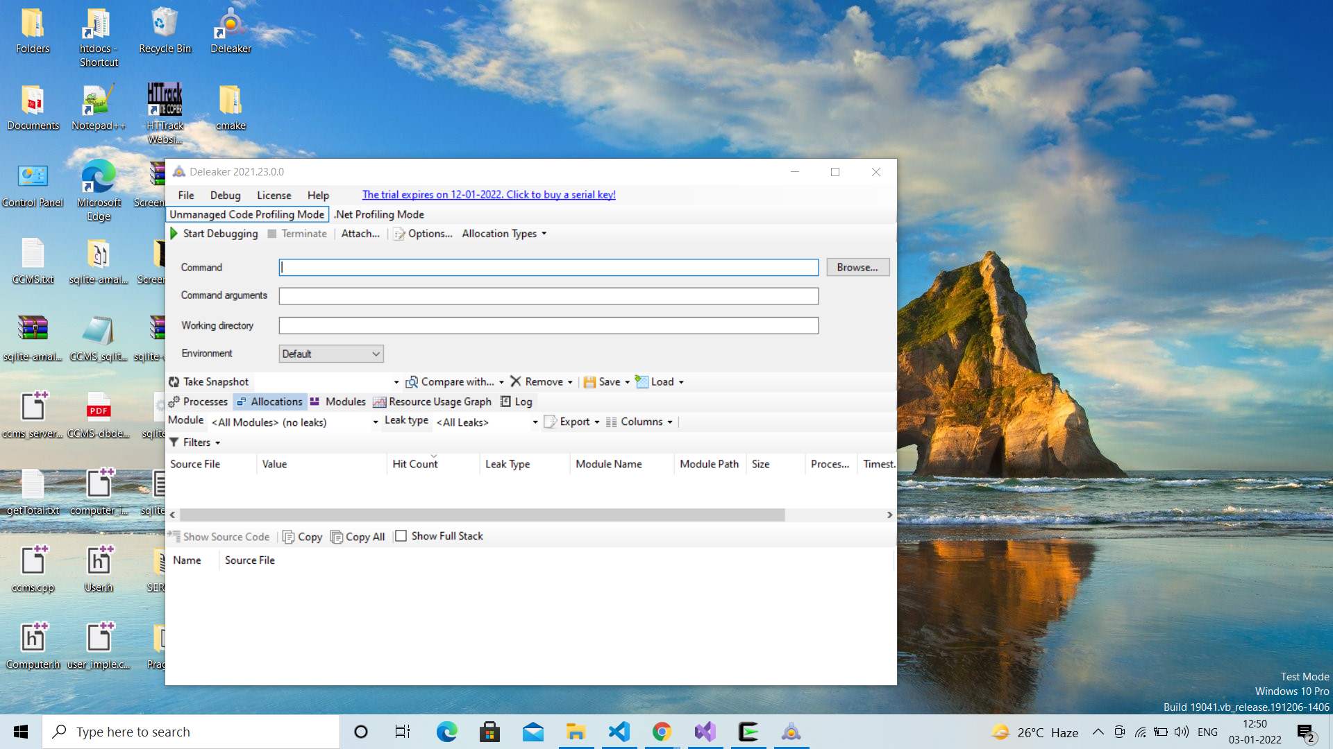

1. Once downloaded it will register itself automatically with the Visual studio.
2. Open Visual Studio. Go to **Menu->Extensions->Deleaker Window.**



1. This window will appear.

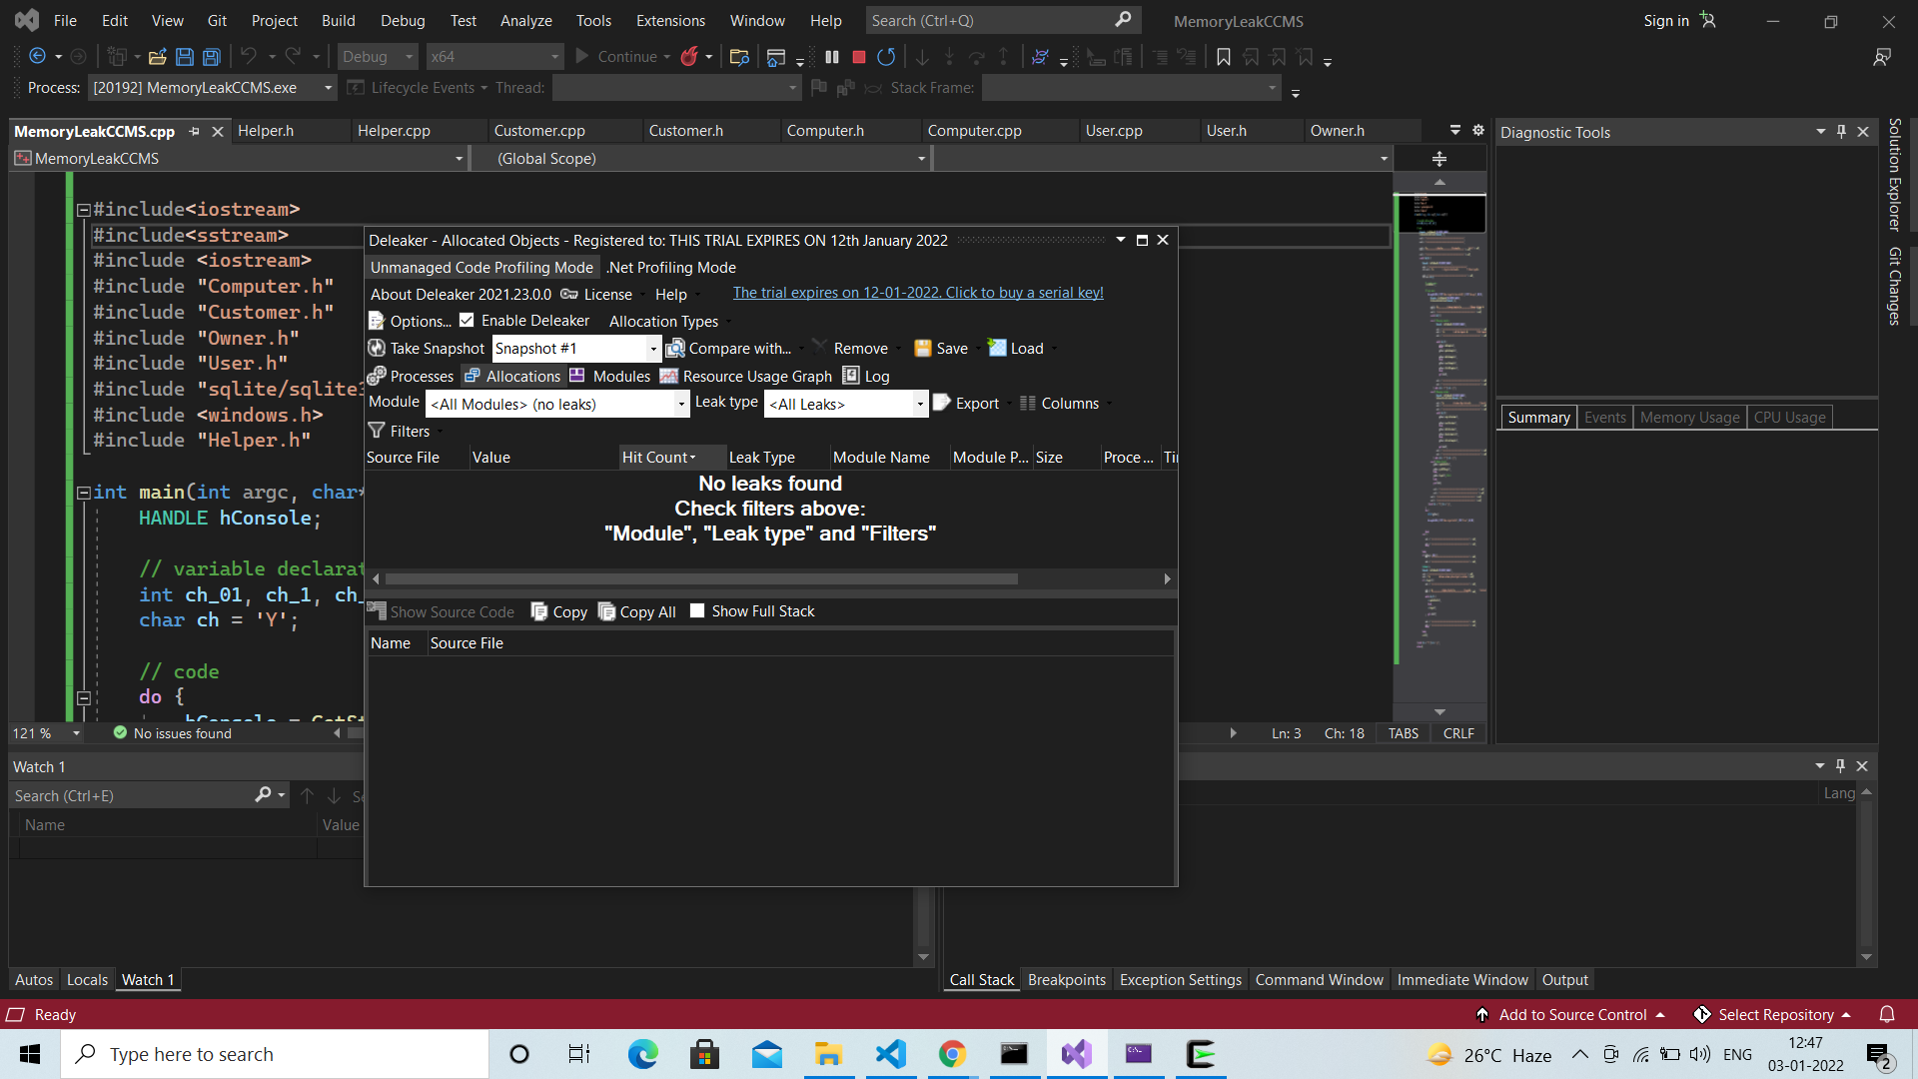

1. Select the Unmanaged code Profiling Method. And enable Deleaker if not enabled.
2. Start the visual studio Debugger and the it will start allocating object to detect Memory leak.



2) Memory Leak Detection using CRT Library(C Run-time Library):

* To enable all the debug heap functions, include the following statements in your C++ program, in the following order:

#define _CRTDBG_MAP_ALLOC

#include <stdlib.h>

#include <crtdbg.h>

* Call the [_CrtDumpMemoryLeaks](https://docs.microsoft.com/en-us/cpp/c-runtime-library/reference/crtdumpmemoryleaks)() Function to Display the Leaks. This function can be called at the exit of the program so that it does not interfere with the logic.